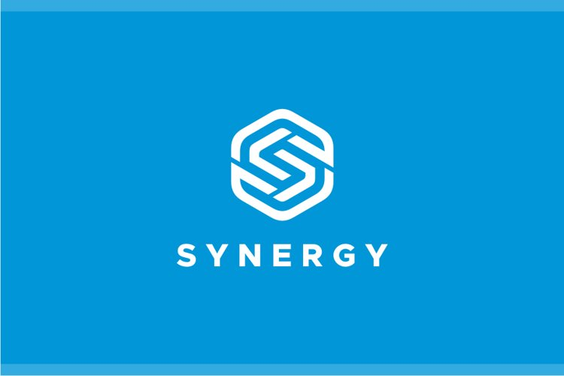

HR PROCESS OPTIMIZATION AT SYNERGY ENTERPRISE

SUBMITTED TO | Global Board of Directors - Synergy Enterprises | SUBMITTED BY | Business Analyst Team
TO THE ATTENTION OF | Chief Human Resources Office(CHRO) | POINT OF CONTACT | Head, HR Technology Transformation Office
ADDRESS | Synergy Enterprise Global HQ, London, UK | ADDRESS | London, UK
PHONE | +44 20 7123 4567 | PHONE | +447776725801
EMAIL | Hr.digital@synergyglobal.com | EMAIL | Asekhameefeomo@yahoo.com
DATE SUBMITTED | October 2025 | DELIVERY METHOD | Electronic Submission via Email

EXECUTIVE SUMMARY
Synergy Enterprises, a multinational FMCG manufacturer with operations in five continents and over 75,000 employees, currently faces challenges due to fragmented and outdated HR systems across regions. The project aims to implement SAP SuccessFactors, a unified cloud-based HR platform, to centralize HR operations, streamline global processes, ensure compliance, and improve employee experience. The expected outcome is an efficient, cost-effective, and globally consistent HR ecosystem that supports strategic decision-making and enhances workforce engagement.

PROBLEM STATEMENT
The HR function at Synergy Enterprises operates using multiple, disconnected systems for payroll, recruitment, and performance management. This has resulted in fragmented and inconsistent employee data, time-consuming manual processes, limited visibility into global HR metrics, high IT maintenance costs, and compliance risks with data protection and labor laws. These inefficiencies limit HR’s ability to support business strategy and negatively impact employee satisfaction.

PROPOSED SOLUTION AND REVIEW OF OPTIONS
Proposed Solution: Implement SAP SuccessFactors Global HR Suite to integrate all HR functions (Core HR, Payroll, Recruitment, Performance, Learning) under a single platform.
Option | Description | Evaluation
Oracle Fusion HCM | Strong HR features, but higher cost and longer deployment | 8/10
Workday HCM | Modern and user-friendly, but limited regional compliance support | 8.5/10
SAP SuccessFactors | Comprehensive, global, proven for large enterprises | 9.5/10 (Selected)
Predetermined Requirements:
- Cloud-based and globally accessible
- Multi-language and multi-currency support
- Integration with existing ERP and payroll systems
- Compliance with GDPR and regional labor laws
- Scalable for future business growth

BENEFITS OF AN UPDATE
Tangible Benefits:
- 30% reduction in HR operational costs within two years
- 50% reduction in manual HR processing errors
- Unified, real-time HR reporting and analytics
- Lower IT maintenance costs
Intangible Benefits:
- Improved employee satisfaction and engagement
- Enhanced global brand reputation through consistent HR processes
- Data-driven strategic decision-making
- Better compliance with international labor and data laws

FINANCIAL ANALYSIS
Cost Item | Estimated Cost (USD)
Software Licensing (SAP SuccessFactors) | $2,000,000
Implementation & Integration | $1,500,000
Training & Change Management | $500,000
Support & Maintenance (Annual) | $300,000
Total Project Investment | $4.3 million
Expected Financial Gains:
- Annual savings of approx. $2 million from reduced manual work and system maintenance
- Payback period: 2 years
- ROI = 39.5% (based on net gains after 2 years)

IMPLEMENTATION RISKS
Risk | Impact | Mitigation Strategy
Employee resistance to change | Medium | Conduct awareness and training programs
Data migration errors | High | Perform phased migration and data validation
Integration issues | High | Use experienced SAP implementation partner
Cost overruns | Low | Monitor budget through Agile sprints and milestones

IMPLEMENTATION PLAN
Duration: 9 months
Methodology: Agile SDLC
Phases:
1. Initiation & Planning (Month 1) – Stakeholder alignment, project approval
2. Requirement Gathering (Months 2–3) – Business process mapping, system specifications
3. System Design & Configuration (Months 4–6) – SAP setup and customization
4. Testing & Data Migration (Months 7–8) – Pilot testing and regional migration
5. Training & Deployment (Month 9) – Staff training and full rollout
Key Personnel:
- Project Sponsor: CHRO
- Business Analyst Team
- IT Development & Integration Team
- Regional HR Managers

CONCLUSION
The proposed implementation of SAP SuccessFactors will modernize HR operations at Synergy Enterprises, creating a unified global HR platform that enhances efficiency, compliance, and employee engagement. We request project approval and funding of $4.3 million to execute the 9-month rollout and deliver measurable operational improvements within two years.

